Introduction to Enterprise Integration Patterns (EIP)
Enterprise Integration — What Does It Mean?
Definition
Enterprise Integration is the practice of connecting different applications, systems, databases, and services within an organization so they can communicate and work together seamlessly.
In simple words:
Enterprise Integration ensures that all enterprise systems talk to each other and share data reliably.
What Gets Integrated?
1) Applications
CRM ↔ ERP ↔ Billing ↔ HR
2) Data
Databases must share updates.
3) Processes
Business workflows span multiple systems.
4) Services & APIs
Modern microservices need communication.

Enterprise Integration Patterns is a foundational book by Gregor Hohpe and Bobby Woolf that explains standard solutions for integrating enterprise applications using messaging systems.
In large enterprises, different applications (ERP, CRM, billing, microservices, legacy systems, cloud apps) must exchange data reliably. Instead of building custom integration logic each time, EIP provides reusable patterns — proven solutions to common integration problems.
These patterns describe:
- How systems communicate
- How messages are structured
- How messages are routed
- How data is transformed
- How reliability and scalability are handled
Modern tools like Apache Camel, Spring Integration, Kafka Streams, MuleSoft, etc., implement these patterns.

Core Idea of EIP
Instead of direct system-to-system communication:
System A → System B → System C
EIP promotes message-based integration:
System A → Messaging System → System B

This makes systems:
- Loosely coupled
- Scalable
- Fault tolerant
- Easier to evolve
🌉 What Problem Does EIP Solve?
In enterprises, many systems must communicate:
- ERP systems
- Payment gateways
- Web applications
- Microservices
- Databases
- Legacy systems
- Cloud services
Without patterns, integration becomes:
❌ Hard to maintain
❌ Error-prone
❌ Tightly coupled
❌ Difficult to scale
EIP provides proven reusable solutions.

Basic Enterprise Integration Patterns
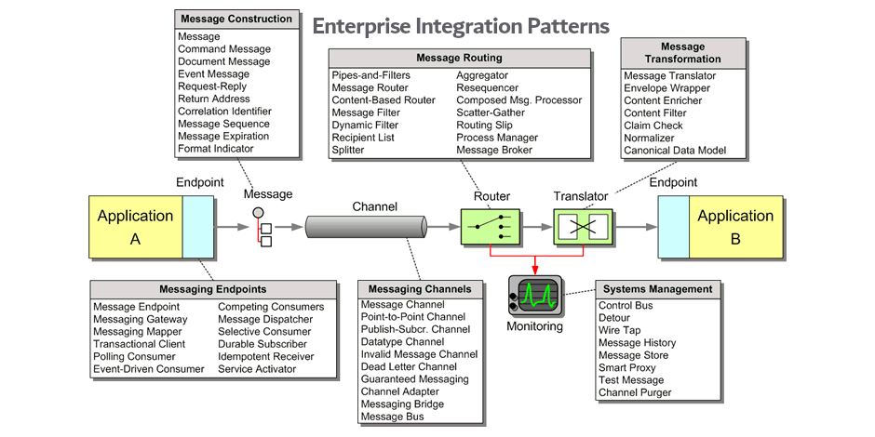
Below are the fundamental patterns every integration developer should know.
1. Message
Data is transferred between systems in the form of a message.
Example: JSON/XML event sent between services.

2. Message Channel
A communication path through which messages travel.
Examples:
- Queue
- Topic
- Kafka topic
- RabbitMQ queue

3. Message Endpoint
An application component that sends or receives messages.
Example:
- REST service publishing events
- Consumer reading from queue

4. Pipes and Filters
Processing pipeline where each component transforms or filters messages.
Input → Filter → Transformer → Validator → Output
Used heavily in streaming and ETL pipelines.

5. Message Router
Routes messages to different destinations based on conditions.
Example:
If region = US → Route A
If region = EU → Route B

6. Message Translator
Converts message format between systems.
Example:
System A JSON → System B XML

7. Message Filter
Removes unwanted messages from a stream.
Example:
Only process orders > $100.

8. Content-Based Router
Routes messages depending on message content.
Example:
Route payments based on payment type.

9. Splitter
Splits one message into multiple smaller messages.
Example:
Order with 5 items → 5 item messages.

10. Aggregator
Combines multiple messages into one.
Example:
Combine shipment updates into final delivery status.

11. Resequencer
Reorders messages that arrive out of sequence.
Example:
Ensure events are processed in correct order.

12. Request–Reply
A sender waits for a response message.
Example:
Service call expecting response.

Pattern Categories (High Level)
EIP patterns are grouped into:
- Messaging Systems
- Messaging Channels
- Message Construction
- Message Routing
- Message Transformation
- Messaging Endpoints
- System Management
- Message Management
Total patterns: 65+ patterns.

Why EIP Matters Today
EIP concepts are everywhere:
Technology | Uses EIP
Microservices | Event messaging
Kafka | Streaming patterns
Apache Camel | EIP implementation
Spring Integration | Messaging flows
Cloud integration | Event-driven systems

Next Learning Step
- Core messaging concepts
- Routing patterns
- Transformation patterns
- Reliability patterns
- Apache Camel implementation
- Kafka-based integration

Lesson -2
📩 Core Messaging Concepts (Integration & Distributed Systems)
Messaging is the backbone of distributed systems, enabling applications and services to communicate asynchronously, reliably, and scalably.
Below are the core messaging concepts you must understand before learning systems like Apache Kafka, Camel, RabbitMQ, ActiveMQ, or cloud messaging services.

🧱 1) Message
A message is the data exchanged between systems.
Typical parts of a message:
- Header (metadata)
- Payload (actual data)
- Properties/attributes
- Timestamp, ID, correlation ID
Example payload:
{
"orderId": 123,
"status": "CREATED"
}

👤 2) Producer (Sender)
A producer creates and sends messages.
Example:
- Order Service sends an event after order creation.

📥 3) Consumer (Receiver)
A consumer receives and processes messages.
Example:
- Email service consumes order events to send confirmation.

📦 4) Message Queue (Point-to-Point)
In a queue, each message is consumed by only one consumer.
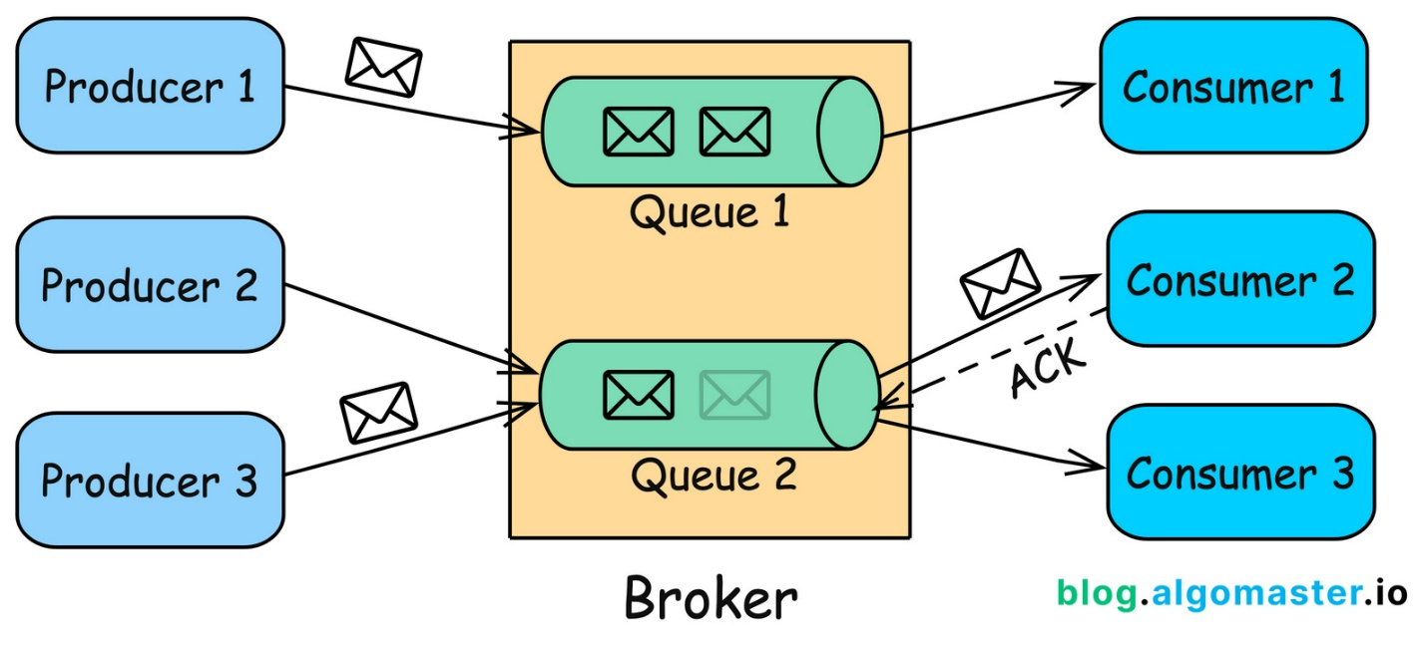

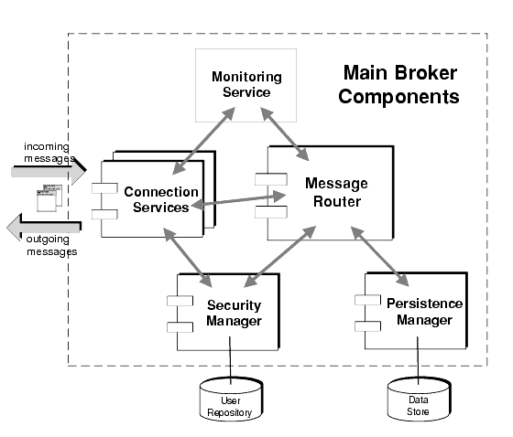
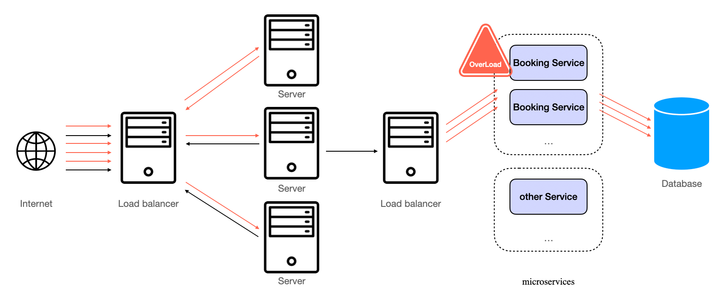
Characteristics
- One producer → Queue → One consumer
- Load balancing among consumers
- Good for task processing
Example Uses
- Order processing
- Payment processing
- Job/task execution

📡 5) Publish–Subscribe (Topic Model)
In Pub/Sub, multiple consumers receive the same message.
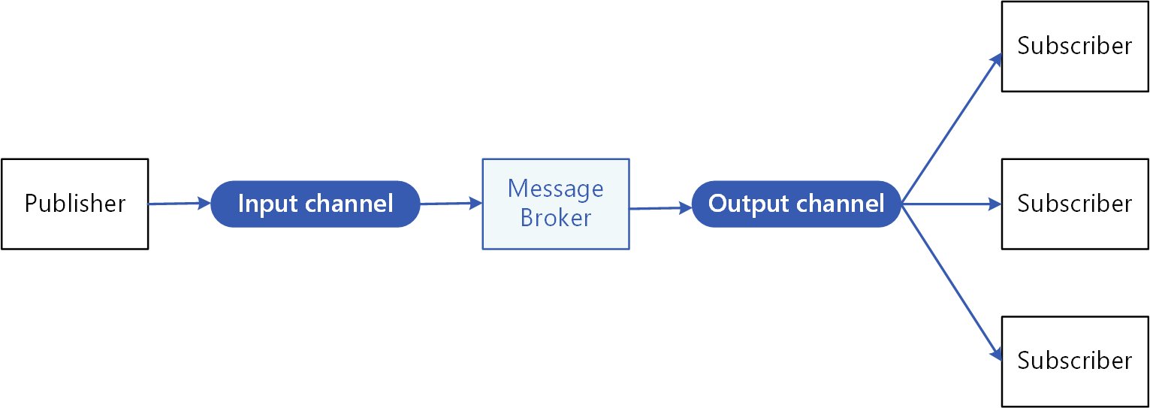
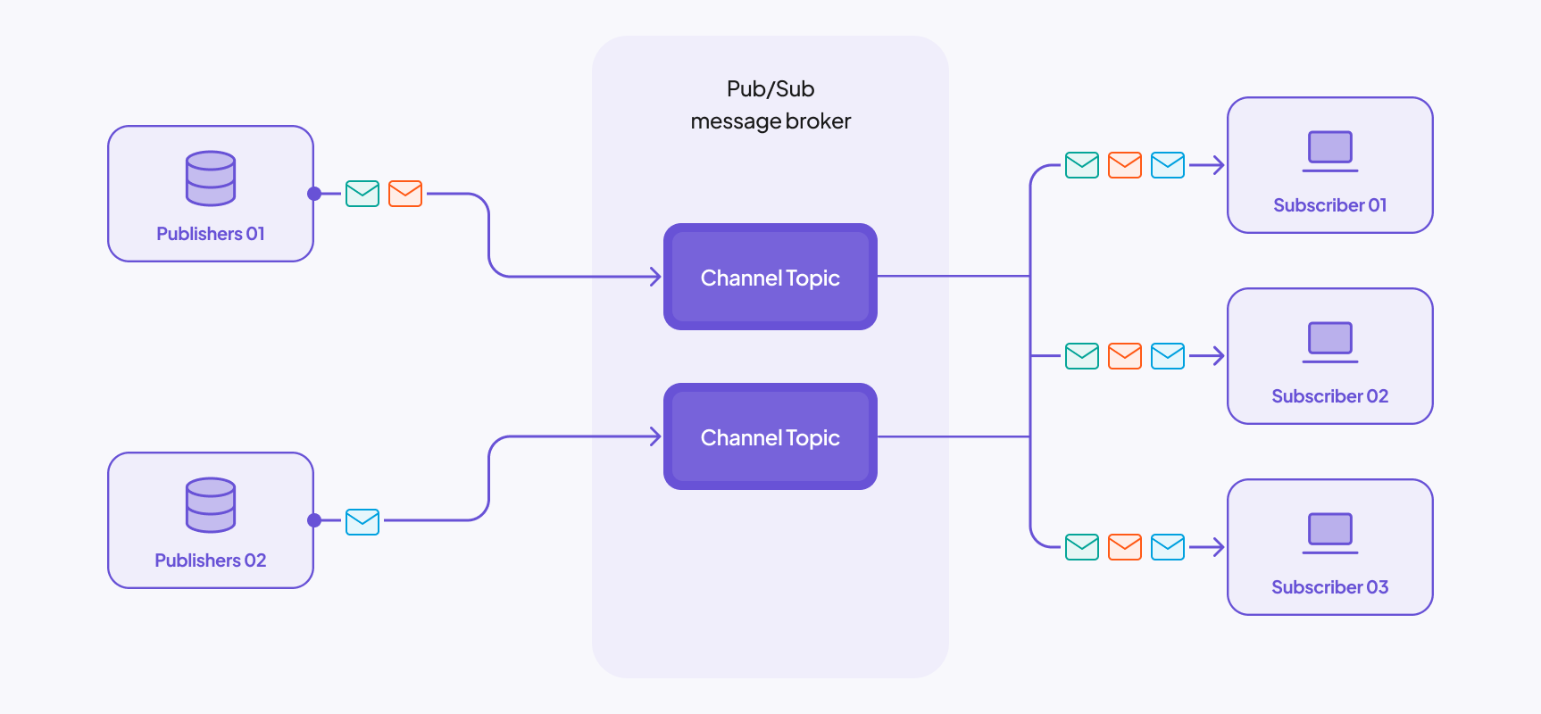
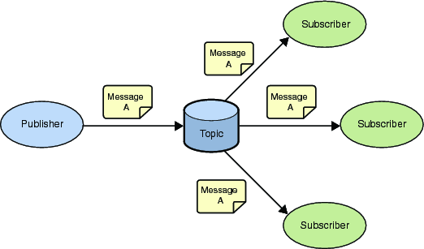
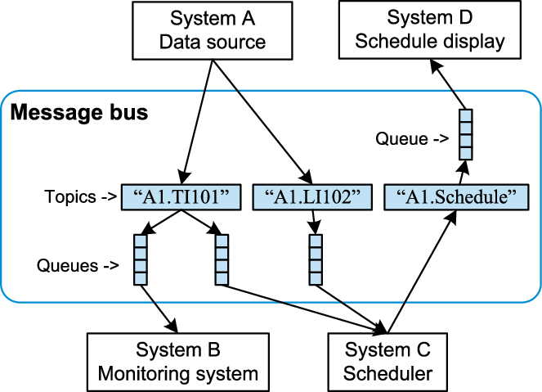
Characteristics
- Producer publishes to a topic
- Multiple subscribers receive messages
- Good for event distribution
Example Uses
- Notifications
- Analytics pipelines
- Microservice event sharing

🧭 6) Message Broker
A message broker manages message routing and delivery.
Broker Responsibilities
- Accept messages
- Store messages
- Route messages
- Deliver messages
- Retry or dead-letter handling
Examples:
- Kafka
- RabbitMQ
- ActiveMQ
- Pulsar

⏳ 7) Asynchronous Communication
Producer does not wait for consumer.
Benefits:
- Faster systems
- Loose coupling
- Better scalability

🔁 8) Message Acknowledgement (ACK)
Consumer confirms message processing.
Types:
- Auto ACK
- Manual ACK
- Negative ACK (retry)
Prevents message loss.

🔒 9) Message Durability & Persistence
Messages can be stored on disk so they survive failures.
Important for:
- Financial systems
- Orders
- Payments

♻️ 10) Retry & Dead Letter Queue (DLQ)
If processing fails repeatedly:
- Retry message
- Move to Dead Letter Queue
Used for debugging and recovery.

🔑 11) Idempotency
Processing a message multiple times should not cause duplicate effects.
Example:
- Avoid double payment if message is retried.

🧵 12) Ordering
Some systems guarantee message order.
Example:
- Bank transactions must remain ordered.

📊 13) Message Partitioning
Messages split across partitions for scalability.
Benefits:
- Parallel processing
- High throughput

🔗 14) Correlation ID
Used to trace related messages across systems.
Helps debugging distributed flows.

🧩 Messaging Concept Map
Producer → Broker → Queue/Topic → Consumer
↓
Storage
↓
Retry / DLQ

✅ Core Concepts Summary
Concept | Purpose
Message | Data being transferred
Producer | Sends messages
Consumer | Processes messages
Queue | One consumer gets message
Topic | Many consumers get message
Broker | Routes and stores messages
ACK | Confirms processing
DLQ | Failed message storage
Idempotency | Avoid duplicates
Ordering | Maintain sequence
Partition | Scalability

